**INTERNSHIP REPORT**

22-05-2017 to 21-06-2017

**TRANSIET ORIENTED DEVELOPMENT WORKS**

**ERRAMUNZIL PROJECT SITE**

Hyderabad Metro Rail – L&T

Erramunzil, Hyderabad.

Submitted by:

M.Hima Sankari

J.Shreya Reddy

M.Ganesh Kumar

**ACKNOWLEDGEMENT**

We are very thankful to our college, Mahindra École Centrale for giving us the connections to our training place at Larsen and Toubro.

We have taken efforts in this industrial training. It could not have been possible without the co-operation and support of the management and engineers at the project site. We are grateful for their guidance and constant supervision as well as for providing necessary information regarding the project.

Some of the names we would like to mention below:

1. Mr. Peer Mohammed J - Project Manager
2. Mr. Rama Sudhakar - Accountant
3. Mr. Jitin Reddy - Planning in-charge
4. Mr. Jose - EHS in-charge
5. Mr. Lokteja - Quality engineer
6. Mr. Ganesh
7. Mr. Vishesh
8. Mr. Eeswar
9. Mr. John Babu

**CONTENTS**

|  |  |
| --- | --- |
| Introduction | 3 |
| Environment, Health and Safety (EHS) | 4 |
| Construction Process | 7 |
| Construction Team Members | 8 |
| Planning | 8 |
| Quality Assessment and Control(QA/QC) | 9 |
| Material Testing | 12 |
| Concrete | 18 |
| Reinforcement | 20 |
| Block Work | 21 |
| Water Proofing | 24 |
| Toilet Water Proofing | 26 |
| Glazing Works | 27 |
| False Ceiling Works | 30 |
| Conclusion | 31 |

**INTRODUCTION**

**Name of the Project:** Hyderabad Metro Rail

**Location:** Erramunzil Colony, Hyderabad

**Architect:** Chelsea West

**Designer:** EDRC (L&T)

**Type of the project:** Lump Sum

**Contractor:** L&T Constructions

**Client:** L&T Metro Rail Hyderabad Ltd.

* Hyderabad Metro Rail Project is the World's Largest Public-Private Partnership Project (PPP) in the Metro Sector.
* Metros and MRTS (Mass Rapid Transport System) are emerging as a major area for infrastructure development in major cities with high population (around 8 Million).
* The Hyderabad Metro Rail Network will cover a total distance of around 72 Km across three corridors:

* Corridor I: Miyapur to LB Nagar
* Corridor II: JBS to Falaknuma
* Corridor III: Nagole to Shilparamam
* In Panjagutta, the entire land is about 3 acres and the built-up area is 6.8lakh sqft.
* The mall block has three basements, ground and five upper floors. There are seven screens.
* The block is sub-divided into two by an expansion joint.

**ENVIRONMENT, HEALTH AND SAFETY (EHS)**

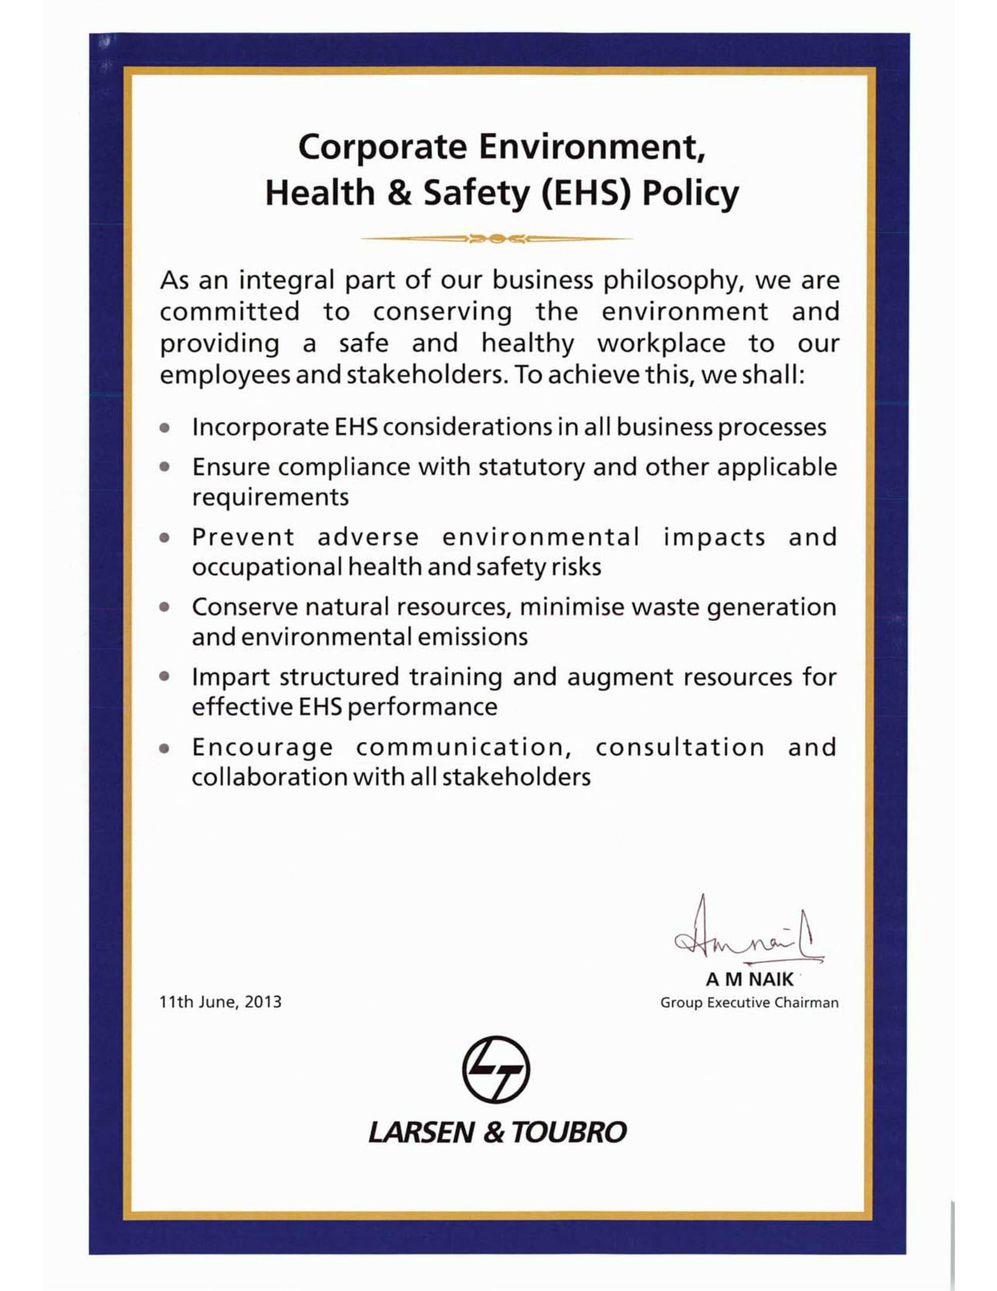

**ENVIRONMENT**

* **Soil Contamination**
* Construction waste which is about to disposal those will be accumulated on concrete hard surface to avoid soil contamination.
* Excavation shall not be carried out from the bund of the water bodies. No debris disposal near any water body.
* **Air Quality monitoring**
* Air ambient quality test conducted by third part to ensure the level of quality air within the site premises.
* All equipment will tested by pollution control board to avoid the air pollution.
* **Noise Monitoring**
* Daily noise monitoring shall be conducted to ensure the acceptable noise level at site premises.
* Noise from construction activities shall not be more than 90 dB and during the night there shall not be any noise activities.
* **Water Testing**
* Drinking water tank shall be cleaned on monthly basis/ as per required at site level.
* Water testing will be conducted by third party to ensure the quality water and PH level.
* **Control dust in atmosphere**
* Spraying of water on dry areas such as a roads and workplaces to control the flying dust in the atmosphere.
* **Illumination**
* Illumination testing shall be conducted during the night to ensure the level of lighting at workplace.
* **Equipment maintenance and fuelling**
* Vehicle/machinery and equipment operation, maintenance and refuelling shall be carried out in such a fashion that spillage of fuels and lubricants does not contaminate the ground soil.
* Storage of fuel area will be made with bounded wall and concrete base to avoid soil contamination.
* Lubrication oil will be collected by authorised vendor for proper disposal of the oil.
* Fuel storage room will be secured and authorised person will be deployed to reduce the unnecessary usage of fuel at site level.
* Oil spillage kit will be arranged to control the spillage of fuel.
* **Waste Management**
* General refuse shall be stored in enclosed bins or units and it should to be separated from construction and chemical wastes.
* Waste materials shall be segregated at site level.
* Separate waste collection bin will be provided at site level with appropriate signage.
* Waste Reinforcement/ plywood will be reused at site level to recycle the waste.
* Weekly basis construction waste materials will be transported out by authorised vendor.

**HEALTH**

* Section In-charge/Engineer shall ensure all workers are screened before engaging them for duties.
* In-charge shall ensure availability of first aider with first aid kit.
* Shed /shelter shall be provided for workers for weather protection along with drinking water.
* Employees will be trained on chemical handling at site.
* MSDS safety precautions will applied while using the substances.
* Required PPEs will be worn to perform the substance involved task.

**SAFETY**

* All transit mixers, tippers, dumpers shall be provided with reverse horns.
* Flagman shall be provided at all exit points of the tippers.
* Flagman shall be provided for the excavator while excavation works & loading excavated materials into the tippers.
* Warning Sign Boards like ‘Men at Work’, ‘Deep Excavation’, ‘Go Slow’ etc. shall be displayed at work area.
* The speed of vehicles moving in the work area shall be restricted to15kmph maximum.
* Levelling staff shall be made of wood.
* If night work is to be carried out the area shall be sufficiently provided with lighting & night work permit ensured.
* It shall be ensured that the safety belts were worn, tied and anchored properly while working at heights.
* Working at height platforms will be barricaded with safety handrail mid and top railing.
* Scaffolding inspection will be carried out before take in use.
* Access ladder will be provided for working at height activates.
* Slab openings will be secured with safety catch net and reinforcement mesh.

**CONSTRUCTION PROCESS**

* Break ground
* Excavation
* Foundation : Concrete forms

Foundation wall

Concrete slab pour

* Utilities : Sewer, Electrical, Water, Gas
* Framing : Roofs, Stairs, Windows
* Roofing
* Weather Resistant Barrier : Rain screen
* Rough Plumbing
* Mechanical Systems : HVAC
* Lighting and Electrical
* Air sealing
* Insulation
* Dry Wall
* Flooring
* Tiling
* Painting
* Cabinets, Shelving
* Finish Plumbing
* Finish Electrical and Lighting
* Certificate of Occupancy
* Modifications
* Moving in

**CONSTRUCTION TEAM MEMBERS**

* Surveyor
* Town Planner
* Architect
* Engineers
* Quantity Surveyor
* Builder
* Estate Surveyor and Valuer
* Project Manager
* Managing Building Project Delivery

**PLANNING**

* “A basic management function involving formulation of one or more detailed plans to achieve optimum balance of needs or demands with the available resources”
* The planning process:
* Identifies the goals or objectives to be achieved
* Formulates strategies to achieve them
* Arranges or creates the means required and
* Implements, directs, and monitors all steps in their proper sequence
* Initially in planning mobilizing the labour, material, and equipment is done.

**QUALITY ASSESSMENT AND CONTROL (QA/QC)**

* Quality is the most important factor which is considered at every stage of construction.
* QA/QC are the control measures which are under taken to demonstrate the accuracy and precision of the work.
* To maintain quality some tests are to be conducted which are referred from the respective codes.
* The tests usually conducted at the project site are
* Compressive strength of cement
* Compressive strength of concrete
* Workability (slump cone test)
* Temperature test for concrete
* Core cutting method

**QUALITY MANAGEMENT SYSTEM**

**GENERAL REQUIREMENTS**

* L&T, Buildings & Factories IC has a well-established and documented Quality Management System (QMS) and is taking appropriate steps to improve its effectiveness in accordance with the requirements of ISO 9001:2008.
* Relevant procedures established clearly specify the criteria and methods for effective operation, control and necessary resources and information to support the operation and monitoring of these processes.
* L&T, Buildings & Factories IC has established procedure for monitoring, measuring and analyzing of these processes and to take necessary actions to achieve planned results and continual improvement of these processes. It has also maintained relevant procedures to identify and exercise required control over outsourced processes, (if any).

**PROCESS FLOW CHART**

**EXECUTION/**

**COMMISSIONING**

**REVIEW & CORRECTIVE ACTION**

**INTERNAL AUDIT**

**MANGEMENT INFORMATION SYSTEM**

**TRAINING**

**ORDER FINALIZATION**

**CUSTOMER REQUIREMENTS**

**PROJECT QUALITY PLAN**

**CUSTOMER STASIFICATION**

**MOBILIZATION**

**LEARNING**

**STATUTORY &REGULATORY REQUIREMENTS**

**PREVENTIVE MEASURES**

**CONQUAS:** The Construction Quality Assessment System was developed by the Building and Construction Authority (BCA) in conjunction with the public sector agencies and the various leading industry professional bodies to measure the quality level achieved in a completed project.

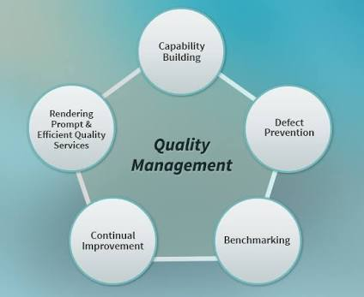

**QUALITY STANDARDS**

|  |  |
| --- | --- |
| **ITEM** | **TO CHECK** |
| Internal wall | Walls meet at right angles.  Surface evenness.  Straight of corners. |
| Rebar condition | Rebars must be securely and properly tied in place.  Rebars must be freed from concrete dropping, corrosion etc. |
| Links, stirrups and trimming | Acc to structural drawings(numbers/sizes)  spacing of links not more than specified. |

**MATERIAL TESTING**

**TESTS ON COARSE AGGREGATES**

* Sieve Analysis

**Procedure**

* The test sample is dried to a constant weight at a temperature of 110 + 5oC and weighed.
* The sample is sieved by using a set of IS Sieves.
* On completion of sieving, the material on each sieve is weighed.
* 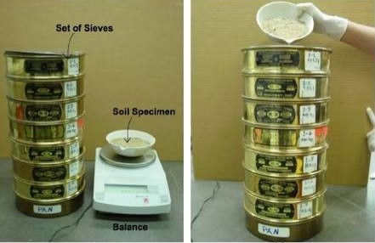Cumulative weight passing through each sieve is calculated as a percentage of the total sample weight.
* Fineness modulus is obtained by adding cumulative % of aggregates retained on each sieve and dividing the sum by 100.

**Reporting of Results**

* The results should be calculated and reported as:
* The cumulative percentage by weight of the total sample
* The wt% of the total sample passing through one sieve and retained on the next smaller sieve, to the nearest 0.1 percent.
* The results of the sieve analysis may be recorded graphically on a semi-log graph with particle size as abscissa (log scale) and the % smaller than the specified diameter as ordinate.
* Specific Gravity
* Water Absorption
* Alkali Aggregate Reactivity
* Los Angele’s Abrasion Value
* Aggregate Impact Value
* Flakiness Index
* Deleterious Content
* Soundness with Sodium Sulphate – 5 cycles

Method of testing: IS 2386 (part 1,3,4,5)-2008

IS 383-1970

**TESTS ON FINE AGGREGATES**

* Sieve Analysis – IS 1542-1992
* Silt Content – IS 383-1970 (RA 2007), IS 1542-1992
* Organic Impurities – IS 383-1970 (RA 2007), IS 1542-1992

Method of testing: IS 2386(part 1,3,4,5)-2008

**TESTS ON ACC BLOCKS** (Auto claved A-rated Concrete)

* Compressive Strength
* Drying Shrinkage

Method of testing: IS 2185(part 3)-1984(RA 2005)

**TESTS ON PLYWOOD**

* Water Resistance test – glue shear strength

Grade designation: IS 1734(part IV)

IS 710-1976

**TESTS ON OPC 53 GRADE**

**Physical** IS 12269:2013

* Fineness – IS 4031(part 2) : 1999 RA 2013

**Procedure**

* Weigh approximately 10g of cement to the nearest 0.01g and place it on the sieve.
* Agitate the sieve by swirling, planetary and linear movements, until no more fine material passes through it.
* Weigh the residue and express its mass as a percentage R1, of the quantity first placed on the sieve to the nearest 0.1%.
* Gently brush all the fine material off the base of the sieve.
* Repeat the whole procedure using a fresh 10g sample to obtain R2. Then calculate R as the mean of R1 and R2 as a %, expressed to the nearest 0.1 percent. When the results differ by more than 1 percent absolute, carry out a third sieving and calculate the mean of the three values.

**Reporting of Results**

* Report the value of R, to the nearest 0.1 percent, as the residue on the 90μm sieve.
* Soundness by Le-Chatlier Expansion – IS 4031(part 3), 1988 RA 2014
* Soundness by % Autoclave Expansion – IS 4031(part 3), 1988 RA 2014
* Setting time Initial – IS 4031(part 5), 1988 RA 2014

**Procedure**

* Prepare a cement paste by gauging the cement with 0.85 times the water required to give a paste of standard consistency.
* Start a stop-watch, the moment water is added to the cement.
* Fill the Vicat mold completely with the cement paste gauged as above, the mold resting on a non-porous plate and smooth off the surface of the paste making it level with the top of the mold. The cement block thus prepared in the mold is the test block.
* Place the test block under the rod bearing the needle.
* Lower the needle gently in order to make contact with the surface of the cement paste and release quickly, allowing it to penetrate the test block. Repeat the procedure till the needle fails to pierce the test block to a point 5.0 ± 0.5mm measured from the bottom of the mold.
* The time period elapsing between the time, water is added to the cement and the time, the needle fails to pierce the test block by 5.0 ± 0.5mm measured from the bottom of the mold, is the initial setting time.

**Reporting of Results**

* The results of the initial and the final setting time should be reported to the nearest five minutes.
* Setting time Final – IS 4031(part 5), 1988 RA 2014

**Procedure**

* Prepare a cement paste by gauging the cement with 0.85 times the water required to give a paste of standard consistency.
* Start a stop-watch, the moment water is added to the cement.
* Fill the Vicat mold completely with the cement paste gauged as above, the mold resting on a non-porous plate and smooth off the surface of the paste making it level with the top of the mold. The cement block thus prepared in the mold is the test block.
* Replace the above needle by the one with an annular attachment.
* The cement should be considered as finally set when, upon applying the needle gently to the surface of the test block, the needle makes an impression therein, while the attachment fails to do so. The period elapsing between the time, water is added to the cement and the time, the needle makes an impression on the surface of the test block, while the attachment fails to do so, is the final setting time.

**Reporting of Results**

* The results of the initial and the final setting time should be reported to the nearest five minutes.
* Compressive Strength at 72±1h – IS 4031(part 6), 1988 RA 2014

168±2h – IS 4031(part 6), 1988 RA 2014

672±4h – IS 4031(part 6), 1988 RA 2014

* Consistency - IS 4031(part 4)-1988

**Procedure**

* Weigh approximately 400g of cement and mix it with a weighed quantity of water. The time of gauging should be between 3 to 5 minutes.
* Fill the Vicat mould with paste and level it with a trowel.
* Lower the plunger gently till it touches the cement surface.
* Release the plunger allowing it to sink into the paste.
* Note the reading on the gauge.
* Repeat the above procedure taking fresh samples of cement and different quantities of water until the reading on the gauge is 5 to 7mm.

**Reporting of Results**

* Express the amount of water as a percentage of the weight of dry cement to the first place of decimal.

**Chemical** IS 4032:1985

* Ratio of Lime to Silica, Alumina, Iron oxide
* Ratio of alumina to Iron oxide
* Insoluble residue
* Magnesia as MgO
* Sulphur content as SO3
* Loss on Ignition
* Chloride Content

**TESTS ON WATER** (for construction & concreting) IS 456-2000

* pH value – IS 3025
* ml of 0.02N NaOH consumed to neutralize 100ml of water using phenolphthalein – IS 3025(part 22)
* Sulphuric acid-methyl orange-indicator – IS 3025(part 23)
* Chloride – IS 3025(part 32)
* Sulphate – IS 3025(part 24)
* Organic Solids – IS 3025(part 18)
* Inorganic Solids – IS 3025(part 18)
* Suspended Solids – IS 3025(part 17)

**TESTS ON ADMIXTURES** IS 9103-1999

* Appearance
* Color
* Dry Material Content(DMC)
* Chloride content
* pH value
* Relative Density

**TESTS ON SOIL SAMPLES**

* Sand Content
* Liquid Content

Plastic Limit

Plasticity Index

* Maximum Dry Density(MDD)
* Optimum Moisture Content(OMC)
* Free Swell Index

IS 2720(part 4, 5)-1985

IS 2720(part 8)-1983

IS 2720(part 40)-1977

**TESTS ON FRESH CONCRETE**

* Slump Cone

**Procedure**

* The internal surface of the mold is thoroughly cleaned and applied with a light coat of oil.
* 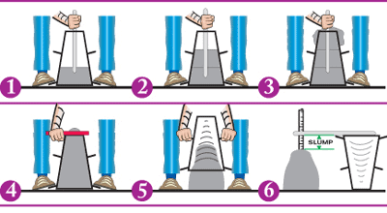The mold is placed on a smooth, horizontal, rigid and nonabsorbent surface.
* The mold is then filled in four layers with freshly mixed concrete, each approximately to one-fourth of the height of the mold.
* Each layer is tamped 25 times by the rounded end of the tamping rod.
* After the top layer is rodded, the concrete is struck off the level with a trowel.
* The mold is removed from the concrete immediately by raising it slowly in the vertical direction.
* The difference in level between the height of the mold and that of the highest point of the subsided concrete is measured.
* This difference in height in mm is the slump of the concrete.

**Reporting of Results**

* The slump measured should be recorded in mm of subsidence of the specimen during the test. Any slump specimen, whom collapses or shears off laterally, gives incorrect result and if this occurs, the test should be repeated with another sample. If, in the repeat test also, the specimen shears, the slump should be measured and the fact that the specimen sheared, should be recorded.
* Compacting Factor
* Vee-Bee

**CONCRETE**

**ABSTRACT**

* A building material made from cement, coarse aggregates, fine aggregates, water, fly ash and chemical admixtures.
* Fluid cement hardens over time.
* The aggregates which retain when sieve analysis test is done with a 4.75mm sieve are coarse aggregates (rock) while the aggregates which pass through are fine aggregates (sand).
* 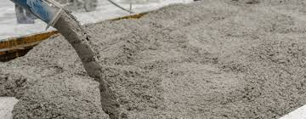Generally, coarse aggregate is blended with the finer aggregates to fill in the spaces left between the large pieces and to lock the larger pieces together. This reduces the amount of cement paste required and decreases the amount of shrinkage that could occur.
* Strength of water decreases with increase in the water content.
* Fly ash is used as a supplementary cementitious material which when used in conjunction with OPC contributes to the properties of the hardened concrete through hydraulic activity. It also reduces the material costs.
* Admixtures enhance the durability, workability or strength characteristics of the concrete mixture.

**GRADES OF CONCRETE**

* From M5 to M100 there are different grades of concrete depending on their strength.
* M5 to M25 grade concrete are called nominal mixtures and are plain cement concrete(PCC) while those above M25 are made using design mix and are reinforced cement concrete(RCC).
* The water-cement ratio is determined in IS 456.
* M5 1:5:10
* M7.5 1:4:8
* M10 1:3:6
* M15 1:2:4
* M20 1:1.5:3
* M25 1:1:2

Note: The above are cement:fine aggregate:coarse aggregate ratios.

* RCC used in the site is M30 and is made using design mix.
* The mix design shall be conducted considering the guidelines given in IS 10262 and design parameters specified in IS 456.

**PREREQUISITES**

* The recipe of the mix which is for a grade of concrete, a minimum of six cubes from three batches shall be cast and tested for its compressive strength for 7 and 28 days.
* The workability of the concrete shall be 150mm ± 25mm.
* Curing shall be done for at least 7 days. The curing shall be done using hessian cloth wrapped around and kept damp.

**PRODUCTION**

* The production of concrete is carried out in a concrete batching plant.
* The concrete ingredients shall be taken by weight only, and these shall be discharged into a pan mixer, mixed and then delivered in to hauling transit mixers.
* The concrete shall be produced such that the temperature of concrete at the placing shall not be more than 30°C.
* All the raw materials used for the production of concrete shall be tested.
* Calibration of batching plant shall be carried out once in a month, to its maximum capacity.

**TRANSPORTATION**

* Concrete shall be transported in transit mixers from the point of production to the site.
* The rotating drum shall be covered with wet hessian cloth during summers to control the temperature of the concrete during transportation.
* On a rainy day, the top receiving mouth shall be covered with tarpaulin sheet to protect the concrete.

**REINFORCEMENT**

**ABSTRACT**

* Rebar (reinforcing bar) is an important component of reinforced concrete.
* 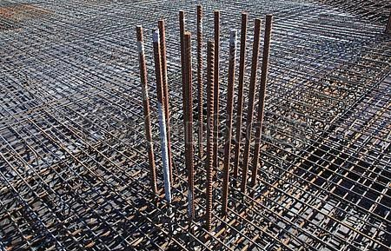It is usually formed from ridged carbon steel. The ridges give frictional adhesion to the concrete.
* Reinforcement is typically made of steel, which has excellent tensile and compressive strength.
* When the beam in question is made of a composite of concrete and steel embedded in it, the capability of the beam to withstand the internal forces increases.
* This enables us to use RCC - *Reinforced* Cement Concrete as a material to cast beams, slabs and columns which can withstand a great amount of internal forces.

**TYPES OF REINFORCEMENT**

* Fe 250- it is mild steel. It is good for tension only. Used on concreting in ancient times.
* Medium tensile steel- not much use in concreting.
* Fe 415 - good as it have resistance to torsion as well as tension.
* Fe 500D, 600D - the D represents *ductile.*These rebar have good ductile property and are reliable for tension, compression and torsion.
* Fiber reinforcements are mixed with concrete homogeneously and then concreting is done.

**TOLERANCE**

* The reinforcement shall be placed with the following tolerances:
* For effective depth 200 mm or less ±10mm.
* For effective depth more than 200mm ±15mm.
* Tolerance for nominal cover should be +10mm and - 0mm.

**TYING OF REINFORCEMENT**

* Make the job ready for receiving reinforcement with coordinates and Level markings and boundaries to be marked with red oxide paint.
* Give clearance for shifting and tying reinforcements.
* Check the reinforcements tied as per drawing and get approval from LTMRHL.
* Cover blocks shall be provided as 2 nos/sqm minimum.
* The cover block thickness shall be used as per standard drawing. Like 30mm, 40mm and 50mm.
* Gauge block shall be used to maintain the wall thickness.
* Reinforcement shall be tied with 18 gauge GI binding wire in double knot.
* For vertical and horizontal members coupler system can be adopted for lapping of reinforcement.
* All vertical reinforcement should be tied in plumb as per drawing.
* All spacing must be provided as per the drawing.
* Spacing of stirrups should be marked as specified in the drawing.
* For vertical/horizontal members the lap length shall be provided at the location as shown in the drawing.

**BLOCK WORK**

**MATERIALS**

* **Solid Blocks**
* Pre cast masonry concrete units of size 400 x 200 x 200mm and 400 x 200 x 100mm shall be used.
* These blocks must conform to IS 2185(part 1).
* They must not be stacked more than 5-6 layers in height.
* For every 5000 blocks, 20 shall be randomly checked.
* **Cement Mortar**
* 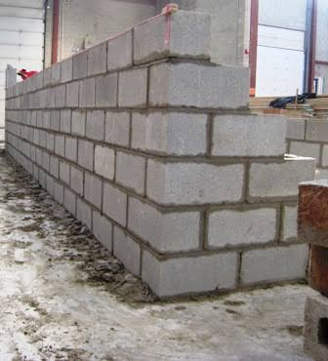The cement shall be OPC 53 grade and confirm to IS 12269, water to IRS:CBC and the sand to IS 2116.
* Fly ash may be used to replace cement upto 30%.
* The cement mortar must have a compressive strength between 5MPa and 7.5MPa at 28 days as per IS 2250-1981.
* Materials required for mortar shall be measured by volumetric batching and are mixed in a mechanical operated mixer.
* Cement and sand in a specified proportion are mixed until a uniform color is obtained. Water shall be added gradually and wet mixing shall be continued.
* The mortar nixed must be consumed within an hour.
* Cement mortar samples shall be collected and tested for its compressive strength at 7 and 28 days.
* The dried and settled mortar should not be used for construction by adding additional water.

**CONSTRUCTION METHODOLOGY**

* **Marking of wall position and layout**
* Block work should be free from debris and any other loose materials.
* The surface of the floor should be level and rough.
* The block work position and layout should be established and marked with red oxide paint with cotton thread.
* The dimension between two walls and diagonal should be checked before and after laying of the first of block units.
* The openings for doors/windows should be marked as per the drawing.
* **Mixing of Mortar**
* The cement mortar must have a compressive strength between 5MPa and 7.5MPa at 28 days as per IS 2250-1981.
* Materials required for mortar shall be measured by volumetric batching and are mixed in a mechanical operated mixer.
* Cement and sand in a specified proportion are mixed until a uniform color is obtained. Water shall be added gradually and wet mixing shall be continued.
* The mixed mortar should be unloaded in GI tray only and should be consumed within an hour of its mixing.
* **Placing of Mortar**
* The mixed cement mortar should be placed along with line and leveled uniformly with mason trowel.
* The mortar joint should be in uniform level and thickness of 10 to 12mm.
* The horizontal/vertical joints should be racked groove of 10mm depth, while the mortar is in green.
* **Laying of Block Course Units**
* The surface area of the concrete that receives the masonry shall be hacked upto 10mm depth at an interval of 75mm using hacking hammers and shall be cleaned thoroughly using a water jet.
* First layer of blocks shall be laid as per the layout marked by the red oxide on concrete surface, giving 10 to 12mm gap for the mortar filling. Mortar shall be filled into the gaps using mason trowel.
* Mortar bed shall be laid over the whole course 10 to 12mm thick uniformly spread and leveled.
* The blocks in the second layer shall be kept such that the joint of both are staggered at 50% of length of the block.
* Mortar shall be filled into the joints as well as on the top surface, line leveled with mason trowel.
* Similarly further layers of blocks shall be laid maintaining the verticality and line.
* Not more than 5 to 6 layers or up to Sill level shall be constructed in one day.
* For each and every layer verticality should be checked using plumb bob.
* For horizontal in plane, an aluminium straight edge of required length should be used to maintain the level at each layer.
* Wall surface shall be cleaned using broom or wire brush to take off all mortar peels & protrusions.
* The horizontal/vertical joints should be racked groove of 10 mm depth to make it good enough to receive plaster/rendering, while the mortar is in green.
* Total wall shall be done in 3 steps – 1st step – up to sill level, 2nd step – Sill level to lintel level, 3rd step –above lintel to beam/slab bottom level.
* In case of a window/door, proper marking shall be given and block work shall be continued around it.
* Top layer shall be laid 100/150 or 200 mm block shall be cut with mechanical cutting machine and laid (below soffit of slab/beam).
* A gap 12 to 20 mm to be filled later with cement mortar shall be left between the wall top & the beam/slab soffit areas.
* **Curing**
* Exposed surfaces of Masonry shall be kept continuously in a damp or wet condition by covering with a layer of sacks, canvas, Hessian or by similar materials and shall be kept constantly wet at least for a period of 7 days.
* 12000 litres capacity of water tanks are filled on daily basis. Each tank is connected to a 1 HP motor pump which is connected by PVC hose pipe for sprinkling water on the solid block masonry walls throughout the building.

**WATER PROOFING**

**Step 1: Water Ponding**

* clearing the surface
* construction of bunds
* filling water- 48-72 hours
* identification of leakages

**Step 2: Grouting**

* Nozzles are placed along the construction joints irrespective of leakages.
* Nozzles are also placed at the identified and marked leakage points.
* The chemical is injected to the V shaped grooves made using the pressure grouting machine.
* The nozzles are then filled with apoxy or cementitious material.

Note: For cementitious material, no water should be there.

* It is allowed to set for 3 days and the extra part is cut and GP2 is used to cover the surface.

**Step 3: Construction of haunches**

* A haunch is created to prevent further leakage at the wall-slab joints.
* It is usually 100x100mm.

**Step 4: Surface Preparation**

* Air blower is used to clear the surface.

**Step 5:**

* Hydrogard is diluted to 50% by adding water and the primer coat is applied.
* Then the first coat followed by the second coat is applied.
* No water is added and the coats are applied with 6 hours time gap between each.
* The first and second coats are applied in different directions.

**Step 6:**

* The second coat is then covered by a geotextile sheet for protection. GSM200 is used.

**Step 7:**

* Leveling is done and bull marks made of concrete are placed.

**Step 8:**

* Ridge line
* Valley line

**Step 9:**

* These lines are then connected to the drain pipe which is 15-20mm below the surface.

**Step 10:**

* Then the geotextile is covered with screed along the bull marks according to the level.

**Step 11:**

* The bunds are then constructed again re-filled with water.
* It serves two purposes:
* Further identification of leakages
* Curing

**TOILET WATER PROOFING**

**MATERIALS**

* **OPC**
* **Water:**
* Water shall be conformed the IS: 3025 and IRS Concrete Bridge code.
* **Hydrogard:**
* Liquid applied water proofing membrane
* **Proofsol LWP:**
* Proofsol LWP is an integral water proofing compound is ideal for use with both concrete and plastered surfaces.

**WORK SEQUENCE**

* Surface preparation
* Water Ponding Test
* Injection Grouting/Pressure Grouting
* Fixing of nozzles
* Mixing of grout materials
* Grouting
* Provision of toilet plumbing pipe lines
* Filling/Arresting of Gap around Plumbing and MEP lines
* Application of Water Proofing coat
* Surface preparation
* Provision of haunches
* Application of primer
* First and second coat application
* Protective Layer Finishing
* Cement concrete on floor
* Water proof plastering
* Laying of Brick bat Coba/AAC Block bat coba
* Curing

**GLAZING WORKS**

* The term 'glazing' refers to the glass component of building's façade or internal surfaces.
* Historically, the installation of glazing was generally undertaken by a specialist glazier, but today it is possible to purchase an entire window which can be fitted by a general contractor.

**GLASS**

* Glass is an amorphous non crystalline solid which is often transparent and has widespread practical, technological and decorative usage.
* The most familiar types of glass are based on the chemical compound silica, the primary constituent of sand.

**TYPES OF GLAZING**

There are many different types of glazing with different manufacturing processes, strength, energy efficiency, appearances and so on. The most common include:

* **FLOAT GLASS-** This is named after the modern process used to create large, thin, flat panels from molten glass which is floated onto a pool of molten metal such as tin.
* **ANNEALED GLASS-** This is a piece of float glass that has been cooled in a slow and controlled manner.
* **HEAT STRENGTHENED GLASS-** This is made from a sheet of annealed glass reheated beyond its annealing point of around 1200 degrees Fahrenheit and then cooled slowly. Heat strengthened glass may be twice as strong as annealed glass, but may still need to be laminated for use in buildings.
* **FULLY TEMPERED GLASS-** Tempering is the process by which annealed glass is heated in the same way as heat strengthened glass. The glass is cooled more rapidly which allows the internal portion of the glass to remain fluid for longer than the outer surfaces. This means that an equal amount of tensile and compressive stresses are formed across the glass which allows it to become in the order of four times as strong as annealed glass. This is used as a safety glass, as it shatters into small granular pieces rather than sharp shards, reducing the risk of injury.
* **HEAT SOAKED TEMPERED GLASS-** This is used as a means of testing glass panes that are to be used in safety critical situations, such as a glass railing.
* **LAMINATED GLASS-** Laminated glass is used where glazing must remain intact if it is broken, either for safety or security reasons. It is made by fusing two or more layers of glass with inter-layers of polyvinyl butyral (PVB) through the use of heat and pressure. If it is made using heat strengthened glass, the pane will break into large pieces but will be held in the frame by the PVB inter-layer. If it is made from tempered glass, the sheet may fall out of the frame but will mostly stay together due to the inter-layer.
* **WIRED GLASS-** This is most often used as a fire resistant glass because the wire holds the glass in place if high temperature causes it to break. The wire mesh is better at holding glass in place than the PVB films used in laminated glass.
* **LOW-EMISSIVITY GLASS-** The term 'low-e glass' is used to describe glass that has a coating added to one or more of its surfaces to reduce its emissivity so that it reflects, rather than absorbs, long-wave infra-red radiation.
* **SELF-CLEANING GLASS-** A transparent coating can be applied to glass during the manufacturing which reacts with the sun's UV rays to break down dirt and grime which forms on the outside of the windows, and when it rains, the decomposed dirt natural rinses away. The coating has hydrophilic properties which mean it attracts water over its entire surface, avoiding unsightly uneven water marks.

**ADVANTAGES**

* Supply of natural daylight
* Protection from cold, wind and rain
* Transparency
* Heat protection
* Sound protection
* Use of solar energy
* Object and personal protection
* Means of design
* Electromagnetic dampening

**STRUCTURAL GLASS SYSTEMS**

Structural glass facades are most easily categorized by the structure types that support them.

* **STRONGBACK SYSTEM-** Simplest form of structural support for a glass wall, but are only useful in relatively short spans of two to six meters usually.
* **TRUSS SYSTEM-** They employ a planar truss design, often in a hierarchical system that may combine other element types including tension components.
* **CABLE TRUSS-** Type of truss system that utilizes a minimalist structural form called a cable truss.
* **GRID SHELLS-** Grid shell structural systems are another means to minimalize the visual mass of structure.
* **CABLE NET-** If the spreaders were also to be removed from Cable Truss systems, a system is called net is subsequently achieved. The glass is supported by a net geometry of pre-tensioned cables.
* **GLASS FINS-** In this technology the glass plates are suspended and laterally stiffened by the use of glass fins set perpendicular to the plates at the vertical joints between them.

**GLASS FOR GREEN BUILDINGS**

* Reflective glasses come with reflective coating that filters heat and let optimum light into the building.
* Reduce the heat gain inside the building and thus reduces electricity and cooling costs.
* Allow optimum light (natural day lighting) inside the building, and thus reduces the cost for artificial lighting.

**PROCEDURE**

* **GUIDE FOR WORKMANSHIP**
* Surface preparation
* Framing
* Setting blocks
* Structural spacers
* Detail drawings
* Pre-installation meeting
* Adhesion testing
* **GUIDE FOR SEALENT APPLICATION**
* Cleaning
* Priming
* Masking
* Sealant application

**FALSE CEILING WORKS**

* A dropped ceiling hung below the main (structural) ceiling.
* A typical dropped ceiling consists of a grid work of metal channels in the shape of upside down T, suspended on wires from overhead structure.

**METHOD FOR FIXING THE FALSE POP FALSE CEILING**

* Fixing the framework directly to the beams or plater ceiling.
* Fixing a suspended framework to a plastered ceiling.
* Fixing vertical struts to the supports.
* Fixing the wall supports and framework members.
* Apply the insulation: insulation panels are then fitted over the framework member.
* Fix the first row of ceiling panels.
* Cutting panels to length.
* Finishing the joints: filling the gap with grouting paste and putty knife.
* Edging profile: for a neat finish in the corners, cut the ends of finishing strips at 45 degrees.

**ADVANTAGES**

* A false ceiling hides the duct work, pipes and electrical wires giving the ceiling a clutter free neat and clean look.
* It is easy to reassemble the panels of a false ceiling in case of repair works.
* A false ceiling plays a key role in acoustics and sound absorption. It is designed in such a way that it adds to noise reduction thus, making the space quiet.
* It is much more economical to install a false ceiling than to get the entire ceiling renovated in case of damages as they are removable.

**DISADVANTAGES**

* One of the major disadvantages of false ceiling is that it can reduce the height of a room by several inches or feet as it is hung below the existing ceiling.
* It requires frequent maintenance and does not have long life. Sagging is possible in case of false ceiling and the ceiling gets decoloured or stained after frequent use for few years.
* False ceilings are not as solid as the traditional ceilings, especially in the case of natural calamities like earthquakes they might turn out to be unstable. Another danger is the falling of installed fixtures.

**CONCLUSION**

The internship helped in gathering the practical work procedure alongside with furnishing the theoretical knowledge learned till date. It was scheduled and comprised of different sections like safety, quality control and planning. The importance of safe working, adopting safety and preparedness for any sudden accidents at site were explained in the safety department. The purpose of the quality control department is continuous checking of the materials at the site and preparation of design mixes. We were taught some of the tests of the materials present at site. The work of the planning engineer, the procedure of proper planning and scheduling of construction work as per progress of work. This knowledge was shared in the planning department. Shuttering procedures, different construction works and all the safety measures adopted were clearly explained. Apart from technical knowledge we are grateful enough to the engineers who shared their work experience with us. There are a lot of things which cannot be learnt from any books or institution but an exposure to such a construction site can only provide. Such construction site related essential terms and knowledge of work will help us throughout our work life.

I would once again like to thank L&T Constructions Limited for giving us this opportunity and we look forward to working with this company in the near future. Hopefully, this gaining in the small time duration will help us throughout our life.